**National University of Computer and Emerging sciences**

# 

## Objectives:

* To learn and understand the working of Decoders

## 2-to-4 line decoders

74LS139 IC contains two fully independent 2-to-4 line decoders with active low enables. The function table and connection diagram for this IC are shown below:

Function Table

|  |  |  |  |  |  |  |
| --- | --- | --- | --- | --- | --- | --- |
| **Enable** | **Selection Inputs** | | **Outputs** | | | |
| **G** | **B** | **A** | **Y0** | **Y1** | **Y2** | **Y3** |
| H | X | X | H | H | H | H |
| L | L | L | L | H | H | H |
| L | L | H | H | L | H | H |
| L | H | L | H | H | L | H |
| L | H | H | H | H | H | L |

H= Logic High, L= Logic Low, X= Don’t Care

Connection Diagram

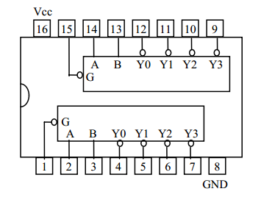

## 3-to-8 line decoders

74LS138 IC contains 3-to-8 line decoder. The function table and connection diagram for this IC are shown below:

Function Table

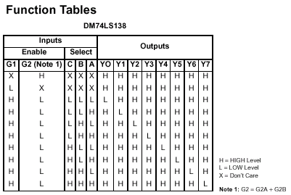

Connection Diagram

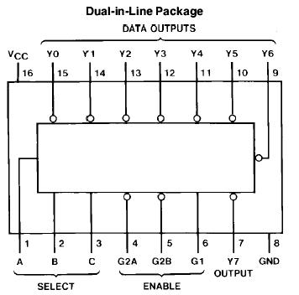

## 

## Problems / Assignments

|  |  |
| --- | --- |
| Problem 1 |  |

Implement 1-bit binary adder using 3x8 decoder and Logic gates on Breadboard

|  |  |
| --- | --- |
| Problem 2 |  |

Implement the following function using 4*1 Mux

F(A, B, C, D) =∑m(1, 3, 5, 6, 8, 12)